PRESS RELEASE

Topic: First electric excursion vessel in Germany with methanol hybrid drive and Reich-Kupplungen coupling system

30 July 2018

Climate-friendly electric vessel on Baldeney Lake in Essen
Coupling system for methanol hybrid drive

Germany’s first electrically driven excursion vessel has been fascinating the regular and charter guests on the Baldeney Lake in Essen since 25 August 2017. Its low noise performance and eco-friendliness is due to the vessel’s combination of methanol tank, fuel cell and motor. The coupling system for the drive has been developed and delivered by the company Reich-Kupplungen.

The complete coupling unit consists of the Multi Mont Sella 100 claw coupling, the Arcusaflex 5.1 flange coupling and two electromagnetic clutches. The engineers of the Bochum-based coupling manufacturer faced the challenge of delivering a switchable propulsion drive system which allows the automated use of the three drive types: purely electric drive, pure diesel drive or combined diesel-electric drive. To reduce the occurring vibrations of the engine, the motor and the drive components, flexible and highly-flexible couplings are combined with the electromagnetic clutches and integrated into a compact housing to form a compact unit.

The coupling unit was installed in an existing passenger vessel as part of the methanol hybrid drive. The conversion took place in the context of “European Green Capital – Essen 2017”. Here, you can see different examples from the city of Essen for how changing the climate policy towards eco-friendly energy sources may look like – on land and on water.

Climate-friendly technology

Especially the shipping industry is still characterised by the exhaust gases and the noise of conventional diesel engines. But the future lies in clean fuels. The new addition to Baldeney Lake is the first vessel in Germany with a motor powered by an eco-friendly methanol fuel cell.

The energy required for operation is generated entirely from renewable energy sources. The energy source ethanol is created by a run-of-river power station located directly at the dam of Baldeney Lake. Carbon dioxide for the electro-biocatalytic methanol production is filtered from the ambient air by means of a container. Using hydroelectric power, the enzymes are stimulated to convert water and carbon dioxide into methanol.

But the amount of methanol gained daily is not enough. This is why additional methanol, also produced in an eco-friendly manner, is bought from Iceland. 330 litres of methanol, which supply enough energy for 16 hours, are then used to generate electricity in the 35-kilowatt fuel cell of the vessel to power the vessel’s electrical system and the battery-powered motor.

The two batteries with a capacity of 50 kilowatt hours each last for four hours in total. Afterwards, they need to be recharged by the fuel cell – or by using a charging cable onshore. In case of an emergency, an additional diesel engine is used.

This is how the methanol hybrid drive works:

- The hydroelectric power station at Baldeney Lake filters carbon dioxide from the air.

- Using electricity and water, the carbon dioxide is converted to methanol, a bioalcohol. Methanol can be stored, transported and filled in just like petrol.

- On board the vessel, the fuel cell uses the methanol to generate electricity and to supply it to the battery-powered motor.

- During voyage, the vessel’s motor only emits as much carbon dioxide as was originally filtered from the ambient air for the methanol production.

- In an emergency, the diesel engine can be activated via the intelligently designed coupling system to charge the battery via the generator as well as to power the propeller directly.

Text information:

385 words, 3,012 character (including spaces)

Image material:

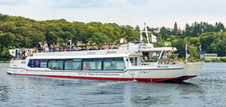
RK_Ausflugsschiff_Baldeneysee_Schiff_©_Peter_Prengel_Stadt_Essen.jpg:
Germany’s first electrically driven excursion vessel has been operating on Baldeney Lake in Essen since August 2017. © Peter Prengel, City of Essen

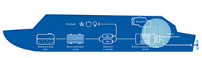
RK_Aufbau_Schiffsantrieb.jpg:
Structure of the vessel’s climate-friendly propulsion system with the main components methanol tank, fuel cell and motor.
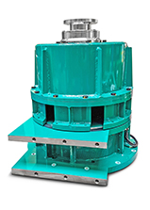
RK_Kupplungseinheit.jpg:
The double flange coupling consists of the MMS 100 claw coupling, the AC 5.1 flange coupling and two electromagnetic clutches.

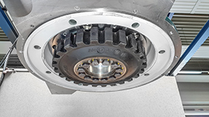

RK_Flanschkupplung_AC_5.1.jpg:
The Arcusaflex 5.1 flange coupling is highly flexible, axially pluggable and has a great damping capacity.

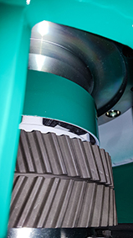

RK_Klauenkupplung MMS_100.jpg:
The Multi Mont Sella 100 (MMS 100) claw coupling is pluggable and easy to install and align.

Image source:
Reich-Kupplungen,
Photo „RK_Ausflugsschiff_Baldeneysee_Schiff_©_Peter_Prengel_Stadt_Essen.jpg“: Peter Prengel, City of Essen

Printing is free of charge. We would appreciate an indication of the source.

About Reich-Kupplungen

The international company Reich-Kupplungen with its headquarters in Bochum is a highly specialised manufacturer of drive components. It focuses on the development and production of a wide range of coupling series with torsional elasticity or torsional rigidity. These are produced in-house to ensure the availability of a high level of expertise in the design and production of couplings for the respective drive.

Dipl.-Ing. Herwarth Reich GmbH
Vierhausstraße 53
44807 Bochum
Germany

Tel.: +49 234 95916-0
Fax: +49 234 95916-16
E-mail: mail@reich-kupplungen.com
www.reich-kupplungen.com

